|  |  |
| --- | --- |
| EXERCICES | POINTS |
| Exercise 1 | 10 |
| Exercise 2 | 10 |
| Exercise 3 | 30 |
| Exercise 4 | 50 |
| **TOTAL** | **100** |

**Exercise 1: Boolean expression**

Demonstrate these equalities using the 7 simplification rules you have learnt.

1. (A or B or C) and (!A or B or C) = B or C

(A or B or C) and (!A or B or C) = (A or B or C) and (B or C)

= True and (B or C)

= B or C

1. (A and B) or (!A or !B) = True

(A and B) or (!A or !B) = False or True

= True

**Exercise 2: Truth table**

1. **A and (A or B)**

|  |  |  |
| --- | --- | --- |
| **A** | **B** | **A and (A or B)** |
| True | True | T and (T or T) = True |
| True | False | T and (T or F) = True |
| False | True | F and (F or T) = False |
| False | False | F and (F or F) = False |

A and (A or B) = A and (A or B)

= (A and A) or ( A and B)

= A or (A and B)

= A and (B or Tue)

= A and True = A

1. **(A and B) or !C or [C and (!A or !B)]**

|  |  |  |  |
| --- | --- | --- | --- |
| **A** | **B** | **C** | **(A and B) or !C or [C and (!A or !B)]** |
| True | True | True | (T and T) or !T or [T and (!T or !T) = True |
| True | True | False | (T and T) or !F or [F and (!T or !T) = True |
| True | False | True | (T and F) or !T or [T and (!T or !F) = True |
| True | False | False | (T and F) or !F or [F and (!T or !F) = True |
| False | True | True | (F and T) or !T or [T and (!F or T) = True |
| False | True | False | (F and T) or !F or [F and (!F or T)=True |
| False | False | True | (F and F) or !T or [T and (!F or F)= True |
| False | False | False | (F and F) or !F or [F and (!F or F)= True |

(A and B) or !C or [C and (!A or !B)]= (A and B) or !C or [C and (!A or !B)]

= !C and (B or True) or [(C and !A) or (C and !B)]

= true

**Exercise 3: Ranges**

1. **Simplify** the expressions
2. a < 3 or a > 3

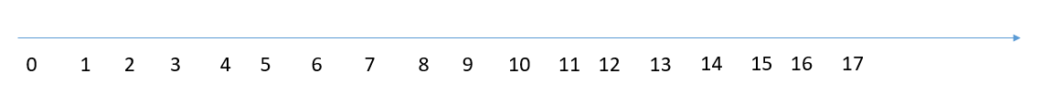

1. a >5 or a < 6



1. a > 2 and a > 12



1. a >= 8 or a > 8



1. a >=0 and a <= 0



1. Draw the shape corresponding to the boolean expression
2. (x = y)

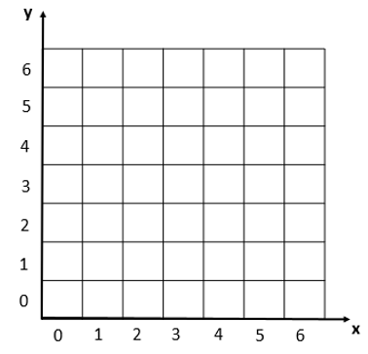

1. (x>2) and not((x>3 and x<4) and (y>2 and y<6))



1. Write the boolean condition for this grid

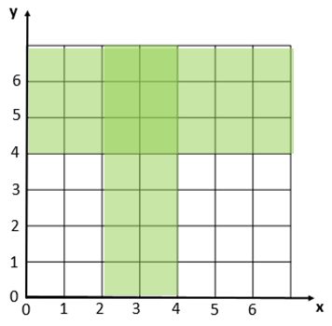

Expression (x>2 and x<4) or (y>4)

**Exercise 4: Flowcharts**

1. Draw the tree of conditions

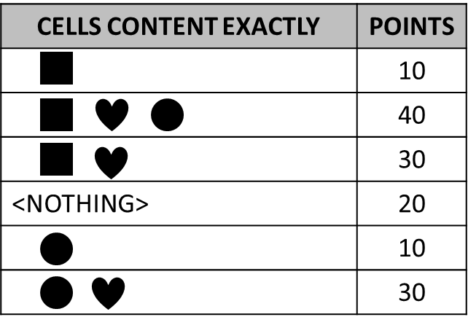

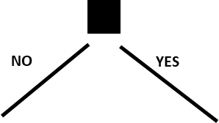

False

False

True

True



True

False

False

True

10

30

40

20

10

30

1. Say what I do thanks to the flowchart below?
   1. It is Monday, it’s hot and I have homework. What I do?

I do work.

* 1. It’s Sunday, it’s cold, it’s not raining, I don’t like bicycle and I’m not tired. What I do? I watch movie.
  2. It’s Friday, it’s cold and raining, I’m tired but I don’t have homework. What I do?

I sleep.

* 1. When do I ride my bike? **Give a boolean expression**

(Hot and not weekend and I don’t have homework and I like bicycle) or (it’s not hot and weekend and not raining and I like bicycle)

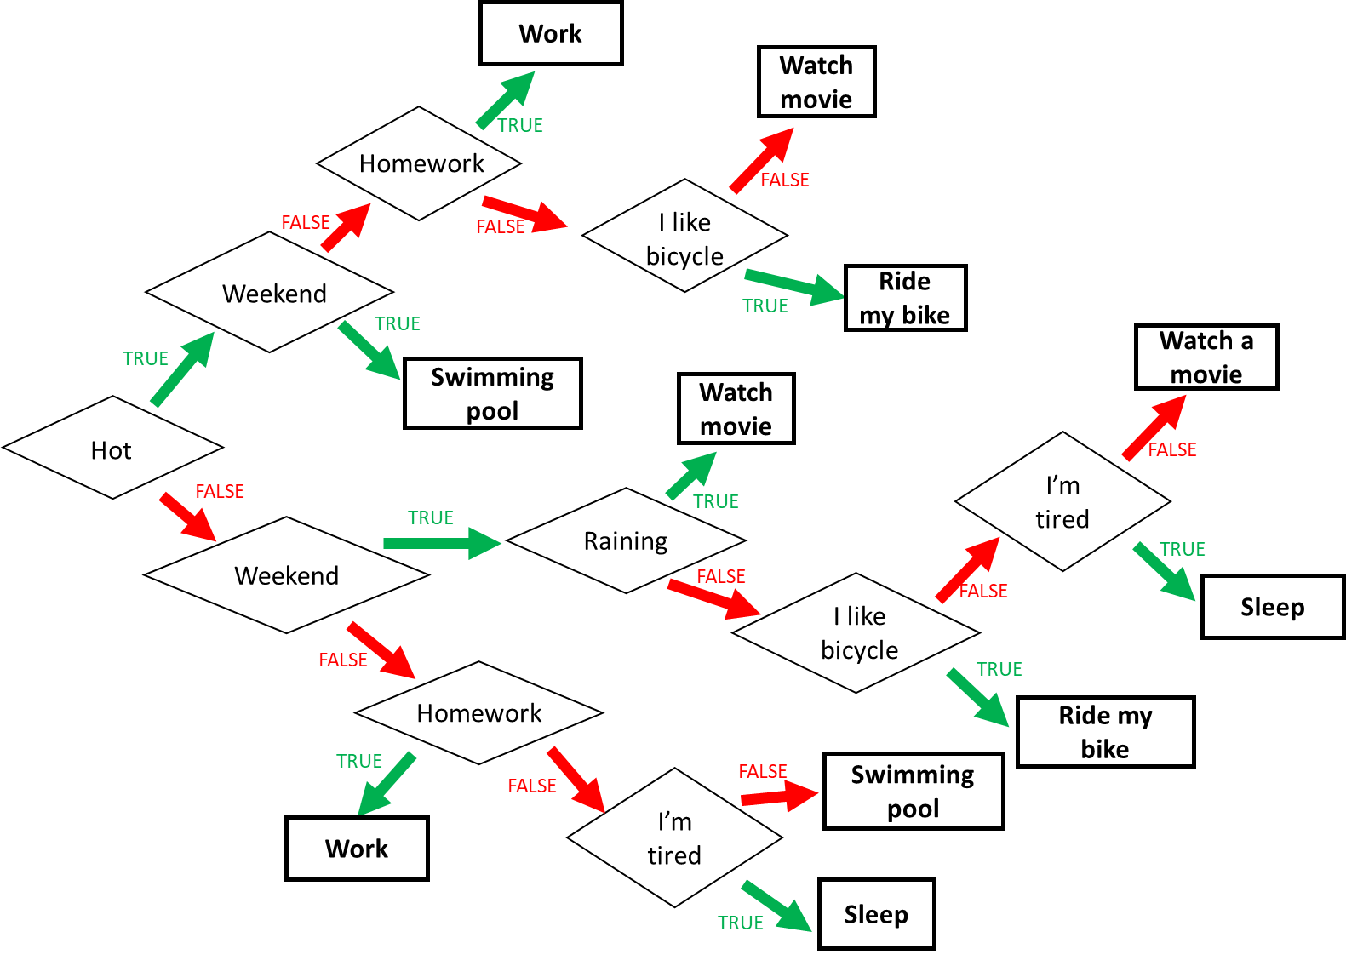

1. Find the boolean expression of **RED** of this flowchart

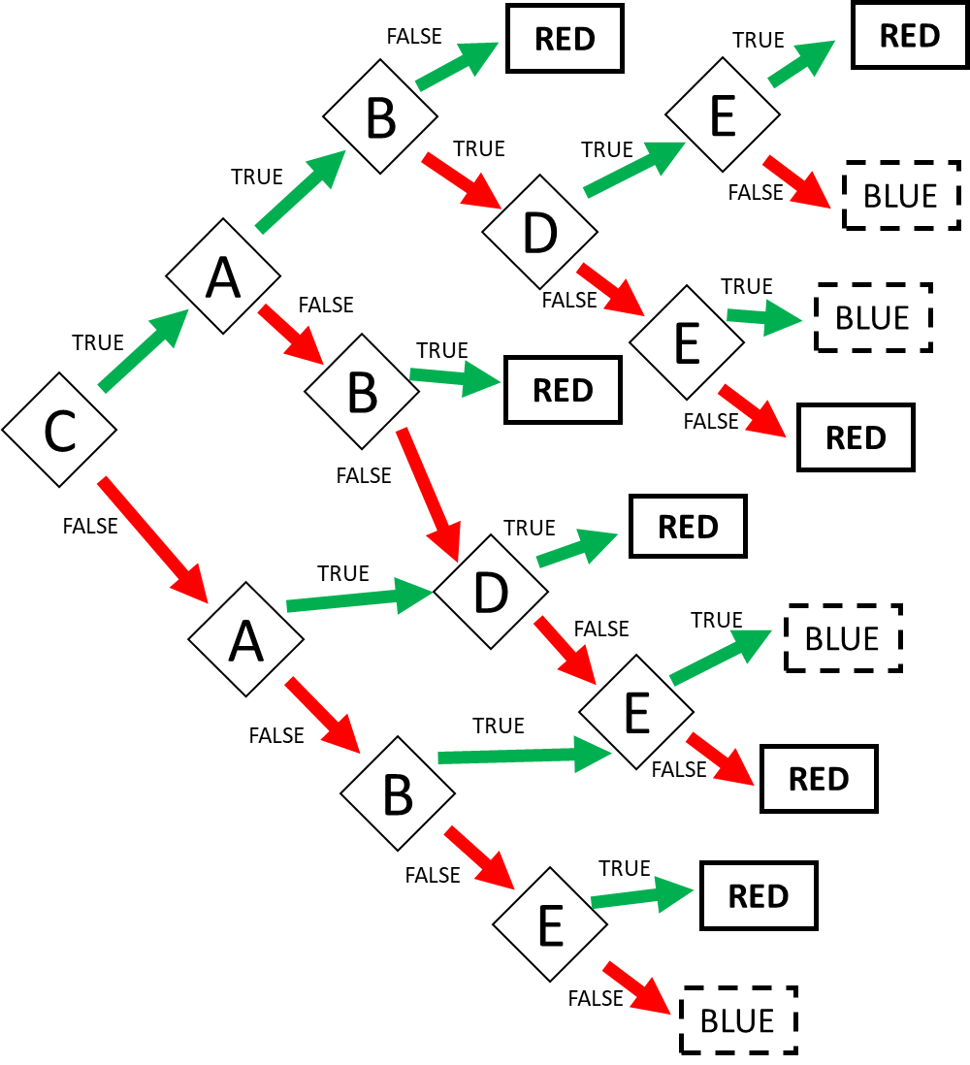

Expression: RED = CA!B or CABDE or CAB!D!E or C!AB or C!A!BD or C!A!B!D!E or !CAD or !CA!D!E or !C!A!BE